Name: Ankith M Mahalathkar (1BM25CS414)

Experiment Title: Design, Implementation, and Remote Management of a Multi-Network Infrastructure Using DNS, HTTP, and Telnet Protocols.

Define the challenge of building a segmented corporate/campus network where end-user workstations must dynamically find a web application server across a layer-3 boundary using domain names, while maintaining remote command-line access to the intermediate networking nodes (Router and Switches).

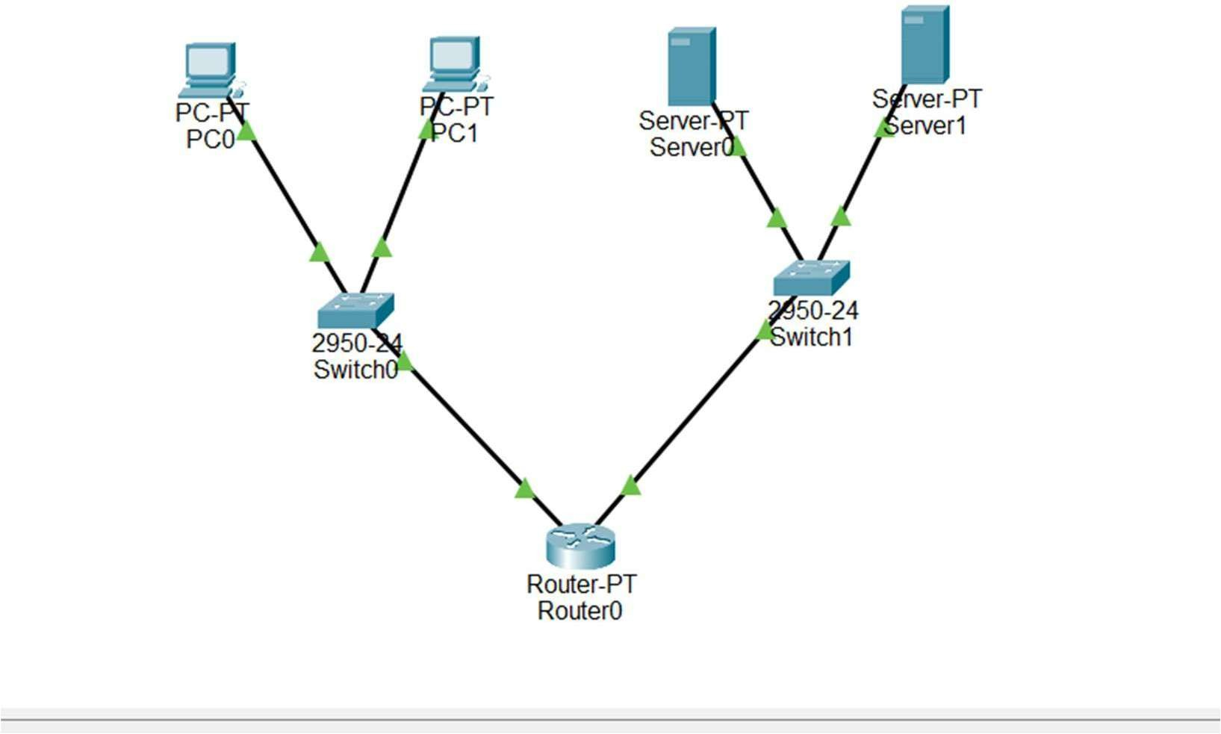

Step 1: Configure the Router's Interfaces & Passwords (The Target)

enable
configure terminal

! 1. Configure the network gateways (if not already done)

interface FastEthernet0/0
ip address 192.168.1.1 255.255.255.0
no shutdown exit

interface FastEthernet1/0
ip address 192.168.2.1 255.255.255.0
no shutdown exit

! 2. Set an Enable Password (Required by Cisco for remote access security) enable password cisco

! 3. Configure Virtual Teletype (VTY) lines for Telnet access line vty 0 4
password bmsce login
end
write

Configure the Client (PC0)
Ensure your PC is on the correct network matching its local gateway so it can reach the router. Click on PC0, go to Desktop -> IP Configuration, and set:
- IP Address: 192.168.1.10
- Subnet Mask: 255.255.255.0
- Default Gateway: 192.168.1.1
Client PCs Configuration (Desktop -> IP Configuration)
Click each PC, open IP Configuration, and type these static values:

PC0:
o IP Address: 192.168.1.10
o Subnet Mask: 255.255.255.0

  - Default Gateway: 192.168.1.1

PC1:
  - IP Address: 192.168.1.11
  - Subnet Mask: 255.255.255.0
  - Default Gateway: 192.168.1.1

Switches Configuration (CLI Tab)

Switch0 (Left Switch): Click it -> go to CLI tab: text
enable
configure terminal interface vlan 1
ip address 192.168.1.2 255.255.255.0
no shutdown exit
ip default-gateway 192.168.1.1
line vty 0 4 password bmsce login
end
write

Switch1 (Right Switch): Click it -> go to CLI tab: text
enable
configure terminal interface vlan 1
ip address 192.168.2.2 255.255.255.0
no shutdown exit

ip default-gateway 192.168.2.1
line vty 0 4 password bmsce login
end
write
- Servers Configuration (Desktop -> IP Configuration)
Even though you are testing Telnet from the PCs, keep the servers configured so your topology stays fully addressing-complete:

Server0 (DNS Server):
o IP Address: 192.168.2.10
o Subnet Mask: 255.255.255.0
    - Default Gateway: 192.168.2.1

Server1 (Web Server):
    - IP Address: 192.168.2.20
    - Subnet Mask: 255.255.255.0
    - Default Gateway: 192.168.2.1
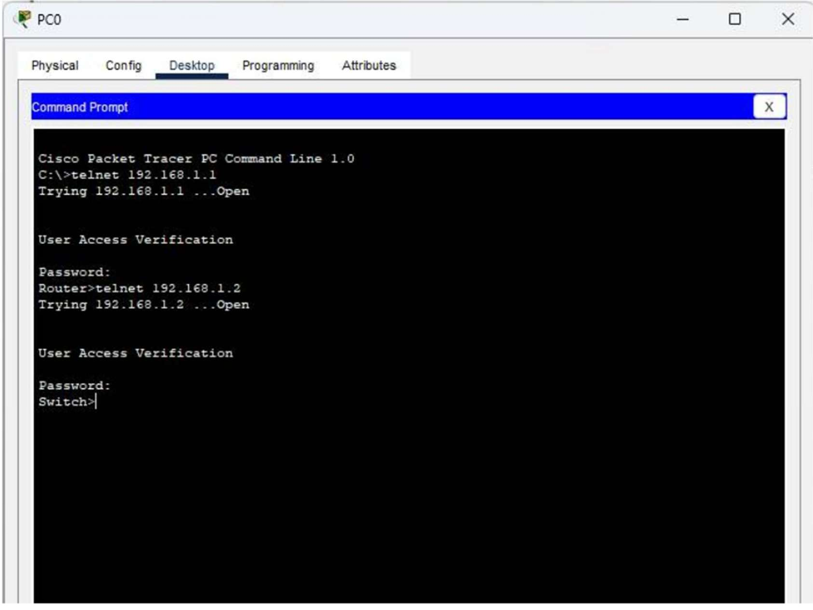

PROCEDURE
  - Router VTY Line Setup: Configure a global password and enable access to vty 0 4 on Router0 using the password bmsce and login commands. Set the privileged administrative access credential via enable password cisco.
  - Switch Management Address Configuration: Initialize the logical management interface on Switch0 by configuring interface vlan 1 with static IP address 192.168.1.2, setting up its default gateway, and adding VTY login security credentials.
  - Client Session Access: Launch the Command Prompt tool on client workstation PC0 and connect to the active local default gateway address using the query text string: telnet 192.168.1.1.
  - Inter-device Session Pivoting: Authenticate with credentials, and from inside the remote router terminal, execute an additional command telnet 192.168.1.2 to safely check connectivity into the managed layer-2 switch console.

OBSERVATION
Upon executing telnet 192.168.1.1 on PC0, the terminal prompts for authentication. Entering the credential bmsce grants console access to the Router> command line environment. Pivoting further via telnet 192.168.1.2 prompts for a second password validation check and successfully switches to the Switch> user mode banner console, confirming functional end-to-end remote administrative control.

CONCLUSION
The implementation of the Telnet protocol has been successfully completed and verified. The observation highlights that networking infrastructure units can be safely configured and managed remotely across distinct layers using VTY lines without requiring physical console cable attachments.

